Digital Research Computers – History
(From www.s100computers.com)
Digital Research Computers were in no way related to Digital Research Inc. in California of CP/M fame. They were located in Garland TX., and started off as an electronic parts and component supplier primarily advertising in magazines and selling through mail order. Somewhat similar to SD Systems and Jade Computer Products.
They started (as did most) in the S-100 board business making RAM and ROM boards. However they also had a few other interesting cards. Worthy of particular note was their S-100 Sound Card. They also made an 8K RAM card for the SWTPC 6800 computer (like Seals Electronics).
Actually their big success came not from S-100 boards but from a single board computer called the "BigBoard" which they came out with in 1980. This was followed two years later by the BigBoard II. They were Z80 based single-board computers designed by Jim Ferguson and provided a complete CP/M compatible computer system on a single printed circuit board, including CPU, memory, a disk drive interface, keyboard and video monitor interface all for less than $500. The printed circuit board was sized so as to allow its attachment to the top of an 8 inch floppy disk drive. The Big Board II added a hard disk drive interface, enhancements to system speed (4MHz vs. 2.5MHz) and enhancements to the terminal interface.
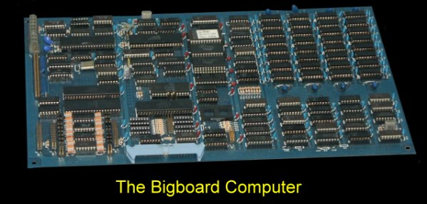
The board really caught on and had a loyal following. Even Xerox Corp. licensed it for use in their 820 Microcomputer system.
I have no further information about the company itself however, its founders or what happened to it.

