PARASITIC ENGINEERING POWER SUPPLY KIT

Errata

26 March 2010 Martin Eberhard

DISCUSSION

The Parasitic Engineering Power Supply Kit has a minor mistake in the bleed resistor circuit for the -16 volt circuit that can be corrected easily. This is how Parasitic Engineering intended the circuit, and how it will actually be once these errata have been implemented:
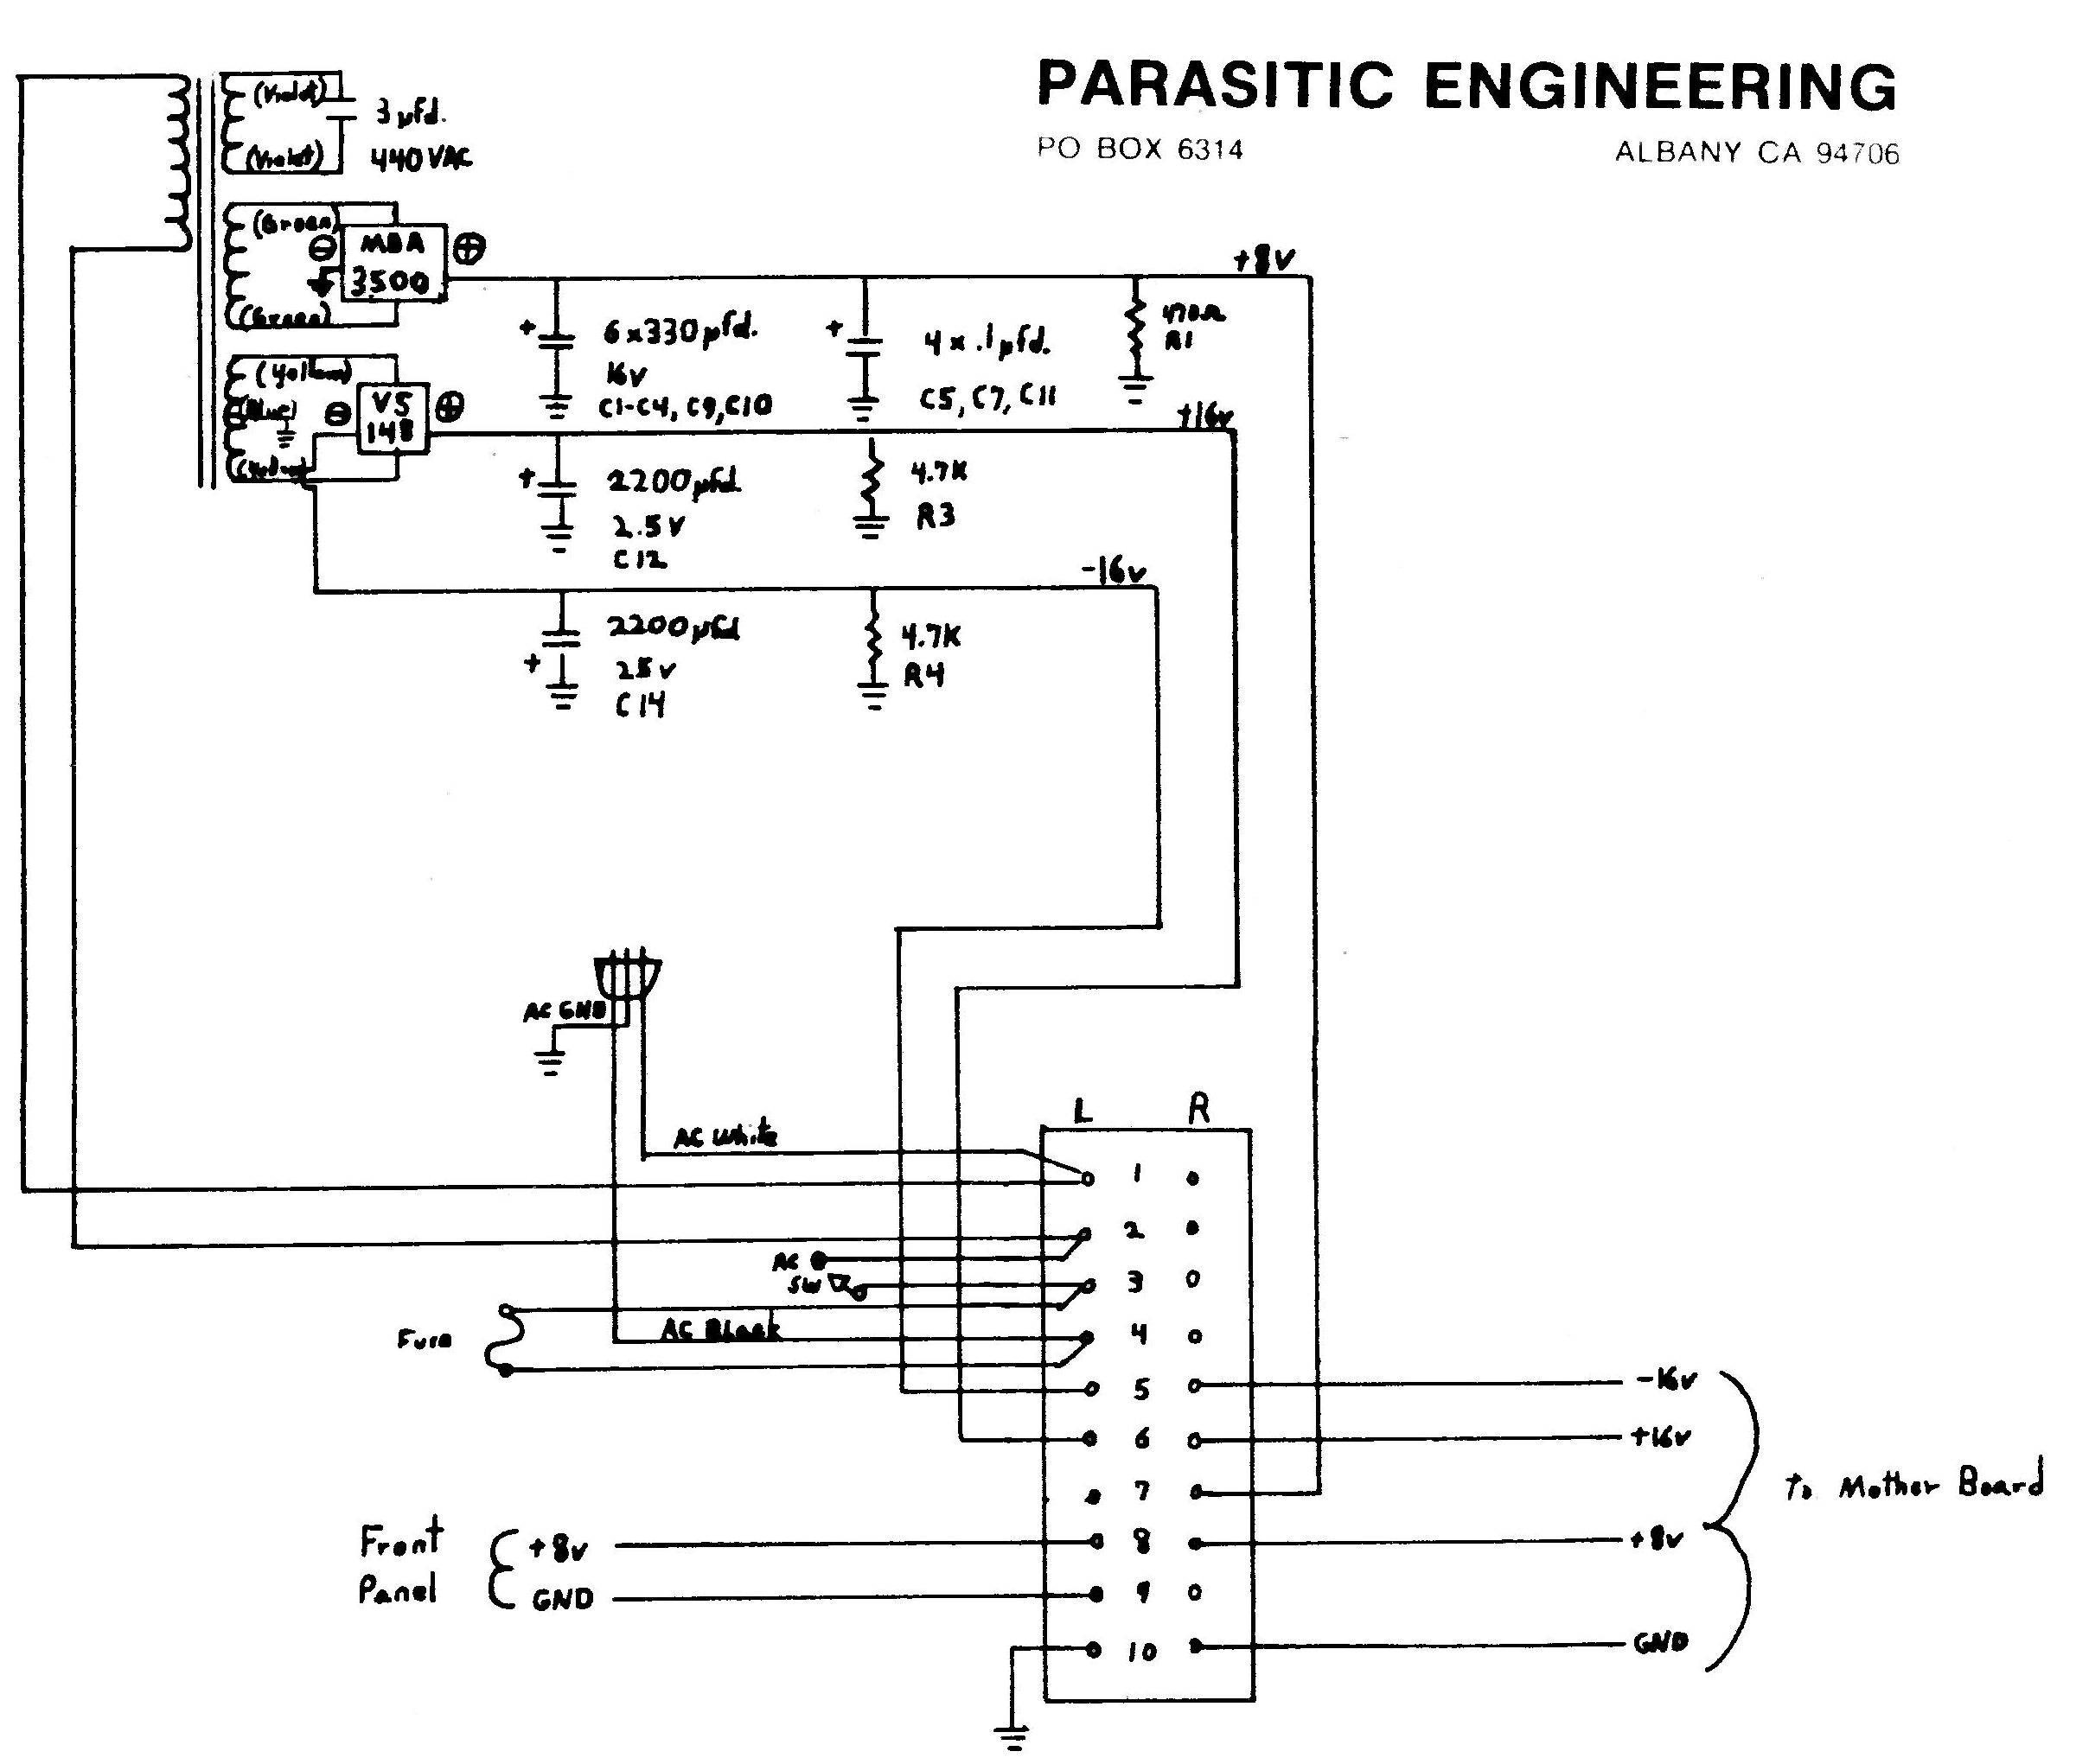

The trouble is that R4 is not actually wired as shown. If the Parasitic Engineering instructions are followed, the circuit is actually like this (Note the incorrect position of R4):
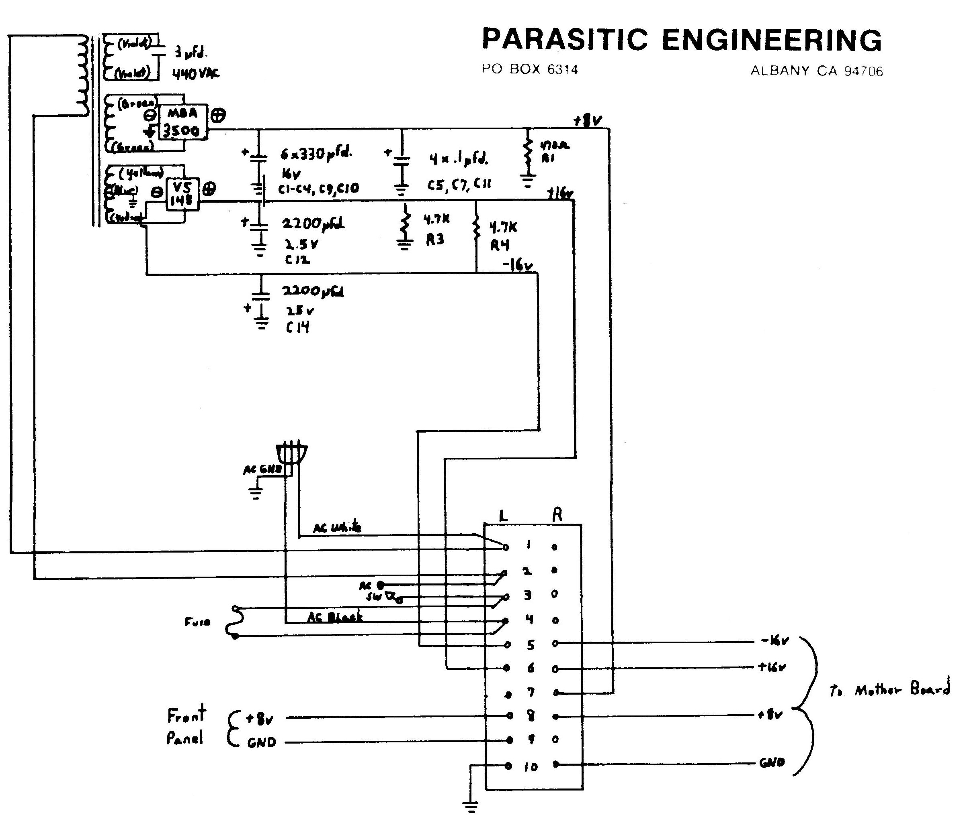

REWORK

( ) De-solder and lift the end of R4 that is farthest from the edge of the PC Board.

( ) Bend R4 around so that its loose end fits into the hole nearest the board edge that was for C13. (C13 had been removed during the Parasitic Engineering modification, as had diodes D5 and D6, which were positioned between R4 and C13.) Solder R4 into its new position.

PCB ASSEMBLY DRAWINGS

Original PCBA – Note the location of R4:
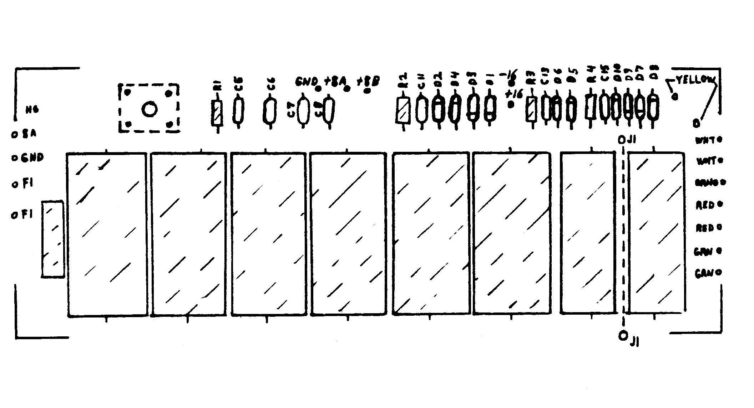
Modified PCBA - Note the new location of R4:
