Northstar History
By NorthStar employee Alan Bowker
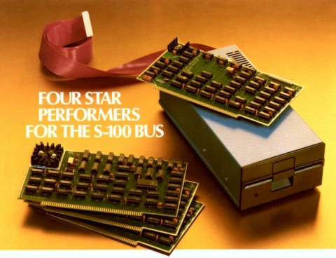
North Star Single Density Disk Controller, Shugart SA-400 Disk Drive and Floating Board Board.
In the early days of 8080 eight-bit computers, my friends and I bought either Altair or Imsai computers. To get them up and running, we toggled in a bootstrap loader so you could read in a BASIC interpreter from either an optical paper tape reader or a cassette tape. After the BASIC was loaded, you could type in your program, such as a lunarlander program.
Then in 1978 came the North Star disk system which was a 5 inch Shugart disk drive that held 89 kilobytes of storage coupled to an S-100 buss controller, cable with North Star DOS and BASIC. It cost $700.00 in kit form and was the first floppy disk system that was affordable to hobbyists.
The front panel of your Altair or Imsai could be addressed to E800 hex, hit the load then run switch, and within a few seconds the North Star DOS prompt would display, (providing you could understand how to configure your computer system for your terminal or video display card.) Once you had the DOS prompt, you could run the BASIC interpreter, load a program, save a file and make file calls from the BASIC. It was absolutely Great!
North Star Computers was the brainchild of Drs. Chuck Grant and Mark Greenberg. Their next product was the North Star Horizon which was an S-100 buss computer with two floppy disk drives, (which soon became double density, then double sided) which gave them a capacity of 360 Kbytes per disk drive. Later an 18 megabyte Winchester drive could be added to the parallel port. Though it competed with other computers and the 8 inch disk format, the North Star Horizon was a very popular computer in the era from 1979 to 1985.
After the Horizon came the Advantage and the Dimension.
A few of us were lucky enough to be a part of North Star during that time.

