NorthStar – History
(from www.s100computers.com)
NorthStar Computers was the brainchild of Drs. Chuck Grant and Mark Greenberg. The first name for the company was Kentucky Fried Computers. Fortunately somebody convinced them to change it early on. The company started in Berkley CA. They originally made a floating point math processor board for the S-100 bus. This had limited success, but they hit the jackpot in 1978 when they came out with the "NorthStar disk system". This was a 5" Shugart disk drive that held 89 kilobytes of storage coupled to an S-100 buss controller along with their own North Star DOS and BASIC. It cost $700.00 in kit form and was the first floppy disk system that was affordable to hobbyists. This was before CP/M had really taken hold. It was a hard sectored (10/track) formatted disk system. Reliable and far better than paper tape or cassette recordings then used at the time. It took well over a year before the Western Digital chip based soft sectored S-100 disk controllers became widespread for such 5" drives. -
Utilizing funds from this great success in 1979 they proceeded to make their own S-100 computer system. The stocked it with their own S-100 boards and motherboard. It was called the NorthStar Horizon. While metal case versions were made, it was commonly seen with its characteristic wooden enclosure.
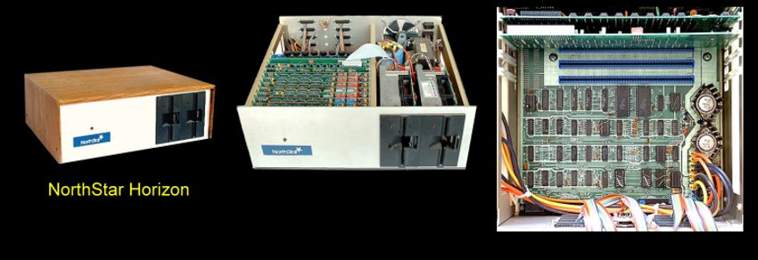
The 10 slot motherboard had its own circuitry for port IO's. The power supply was massive -- even by IMSAI standards. The Horizon was an Z80A-based computer, typically with 16K to 64K of RAM. It has one or two single-sided double density hard sectored floppy disk drives. It had serial interfaces connect it to a computer terminal and a printer. It ran CP/M or NorthStar's own proprietary HDOS.
Later (1982), company came out with an "All in one" system called the NorthStar Advantage. It was well accepted particularly in the academic community. Based on the Zilog Z-80 4Mhz processor, it had 64K of RAM and originally came with two 360K floppy disks. However the cost was high ($4000). The second floppy was later replaced with a 5 Megabyte Winchester hard disk drive. Hard disks were ultimately offered in a 30 megabyte size. The North Star Advantage ran both NorthStar DOS and BASIC as well as CP/M applications. The latter came about initially when a separate group called Lifeboat Associates ported CP/M on to their system. For a time this provided a boost to the unique hard sectored disk system.
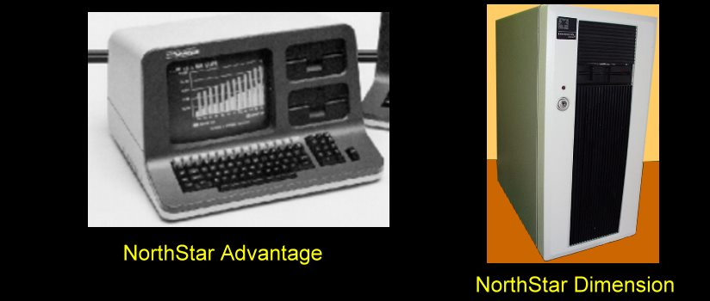
In 1984 NorthStar announced their NorthStar Dimension. This was a server computer. It utilized an Intel 80186 CPU. The Dimension employed multiple screens each connected to a PC-compatible 8086-based slot card that mounted in the server. The screens and keyboards then connected to the workstation cards in the server. The unit shipped with MS-DOS. However Novell NetWare was available as an option.
While initially successful, NorthStar's sales suffered from the company's short-sighted adherence to hard sector floppy drives which made software difficult to port onto NorthStar machines. It was no longer a significant player in the industry by the time cheaper computers, such as the Osborne and the KayPro, were released. The Dimension was NorthStar's last product and while probably ahead of its time it unfortunately did not enjoy the success of NorthStar's previous models.

