Industrial Micro Systems – History
(From s100computers.com)
This was a relatively late comer into the S-100 Bus boards arena. From their name it was clear that they targeted the industrial based market rather than the home/hobbyist community. Unfortunately I can find no information anywhere on the web about the company founders, or the history of the company. From advertisements in Byte magazine back in 1980 it appears they had a sales/head office in Orange, CA and a manufacturing site in Carson City NV. They did however make some real nice boards which I will try to outline here.
Around 1982 the company changed its name/were acquired by Intercontinental Micro Systems and relocated or had a second site at Anaheim CA where they produced a few more new boards for the S-100 bus.
IMS was acquired about 1983 by a group called L/F Technologies. L/F Technologies operated from the same premises at the airport at Carson City, Nevada, as IMS had used. They specialized in multi-user TurboDos. Through the mid-80s they offered both Z80 and 8086 versions.
By 1988 they had changed their name again, to Cubix Corporation. Cubix produced multiuser systems running Unix Sys3 on Intel 80386. The company is still in business, now producing blade servers. See http://www.cubix.com.
(Thanks "RickNel" at Vintage-computer forum for much of this information)
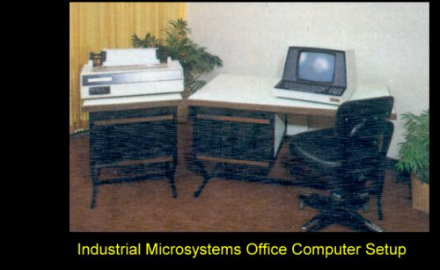
They supplied a complete word processing, data processing office setup complete with a removable platter 16MG hard disk storage system. Both systems contained a 12 slot S-100 motherboard.

