Dynabyte – History
(From www,s100computers.com)
Dynabyte come on to the scene around 1978 with, at the time, a fairly sophisticated complete S-100 series of systems. Right from the get- go they made it clear they were not targeting the home/hobbyist community but instead the small business community. Their machines were priced accordingly, being function for function amongst S-100 computers amongst the most expensive. Nevertheless their computers were well designed and well made. That said, they seem to have left no record of how they were founded or what happened to them. They were located in Palo Alto CA, though the company was registered in Milpiatas (1977), CA. The president was Michael Watt. At one point they had about 100 employees with sales over $10M/year.
They made one basic S-100 system with differing names and internal complexity. They all had a unique outward appearance typically represented by in the picture below of their Dynabyte 5100 system. The family was an upgradable microcomputer system that support 5.25" and 8" floppy drives, and (later) a Winchester fixed disk. The later systems (the 5000 and 6000 series) were are based on the Z80A and later a 8086 CPU, 64K to 1MB of RAM memory under CP/M, and MP/M UNIX, BASIC4 or OASIS operating systems.
They also made Single board controllers (non-S100 bus) for industrial applications.
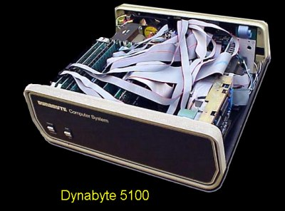
Most of the early systems however (the DB series), contained a 4MHZ Z80 board with one parallel port and two serial ports, a PROM board but typically only 32K of RAM (either static or dynamic) and a single or double density floppy disk controller. All systems were housed with a 12 slot S-100 motherboard. There were boxes with 5" drives (called a DB8/2) , ones with 8" drives (called a DB8/4) and later units with an internal hard disk (shown above).
They seemed to have put a lot of effort into developing an integrated business software package with the system. Providing not only BASIC, COBOL and FORTRAN but also accounting software.

